

|  |
| --- |
| **Activity 2.3.1a Stress/Strain Calculations Answer Key** |

Practice Calculations

Note: Use this sheet to document all steps for Activity 2.3.1 Engineering Calculations.

18,000 lbf

2.0 ft

9.0 in.

Knowns:

W= 9 in.

L = 2 ft

F = 18,000 lbf

Unknowns:

A = Area

⬧ = stress

Equation:

A = L x W

⬧ = F/A

Substitute and Solve:

A = L x W

A = (2 x 12 in.) x 9 in.

A = 24 in. x 9 in.

**A = 216 in.2 = 220 in.2**

⬧ = F/A

⬧ = 18,000 lbf / 216 in.**2**

⬧ **= 83.33 lbf/in.2= 83 lbf/in.2**

Final Solution

⬧ **= 83 lbf/in.2**

Draw:

**1.**

Knowns:

d= .25 in.

⬧ = 63,750 psi

F = 925 lbf

Unknowns:

df = Final diameter

Equation:

A = πr2

df = 2r

⬧ = F/A

Substitute and Solve:

⬧ = F/A

63,750 psi = 925 lbf/( r2)

r2 = 925 lbf / 63,750 lbf/in.2

r2 = .0145 in.2/ 

_________

r = √.004618 in.2

r = 0.06796 in.

df = 0.136 in.

Final Solution

**df = .136 in.**

Draw:

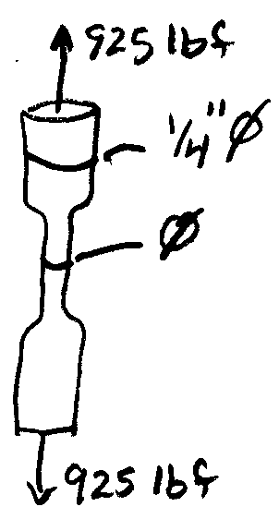

**2.**

.50 in.

P

Knowns:

⬧ = 24,000psi

d= .50in.

Unknowns:

A = Area

F = Tensile Load

Equation:

A = π d2/4

σ = F/A

Substitute and Solve:

A = d2/4

A =  0.50 in.2/4

A = 0.1935 in.2

⬧ = F/A

24,000 lb/in.2 = F/0.1935 in.2

4,712.4 lbf = F

Final Solution

**F = 4,700 lbf**

Draw:

**3.**

1.125 in.

4.0 in.

Knowns:

W= 4.0 in.

t = 1.125 in.

Unknowns:

Equation:

A = W x t

⬧ = F/A

Substitute and Solve:

A = L x W

A = 1.125 in. x 4.0 in.

**A = 4.5 in.2**

⬧ = F/A

⬧ = 32,000 lbf / 4.5in.2

⬧ **= 7,100 lbf/in.2**

25,000 lbf/in.2 = F/4.5in.2

112,500 lbf = F

**110,000 lbf = F**

Final Solution

⬧ = 7,100 lbf/in.2

F = 112,500 LBF= **110,000 lbf**

Draw:

**4.**

8,000 lbf

.266 in.

35 ft

Knowns:

F = 8.0.103 lbf

E=3.0.107 lbf/in.2

= 0.266 in.

L = 35 ft

Unknowns:

A = Area

d = Diameter

Equation:

A =  d2 / 4

= FL / AE

Substitute and Solve:

 = FL / AE



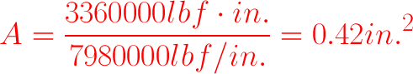

0.4210 in.2 = d2 / 4

1.6842 in.2= d2

0.5361 in.2=d2

0.7321 in. = d

Final Solution

**d = 0.73 in.**

Draw:

**5.**

100 ft

.0144 in.2

270 lbf

Knowns:

F = 270 lbf

A = .0144 in.2

L = 100. ft

 = 0.75 in.

Unknowns:

ε

*E*

⬧

Equation:

ε = /L

⬧ = F/A

E =  /ε

Substitute and Solve:

⬧ = F/A

⬧ = 270 lbf / 0.0144 in.2

⬧ = 18,750 lbf/in.2

⬧ **=19,000 lbf/in.2**

ε =  /L

ε = 075 in. / 100. ft x 12 in.

ε = 0.000625 in./in.

**ε = 0.00063 in./in.**

E =  / ε

E= 18,750 lbf/in.2 / 0.000625 in./in.

**E = 3.0.107 lbf/in.2**

Final Solution

**E = 3.0.107 lbf/in.2**

Draw:

**6.**

3.0 in.

1.25 in.

P

20 ft

Knowns:

E = 30,000,000 lbf/in.2

w = 1.25 in.

t = 3 in.

L = 20 ft

ε = 0.001200

Unknowns:

A

⬧

F



Equation:

ε =  /L

⬧ = F/A

E =  /ε

A = w x t

Substitute and Solve:

E = σ/ ε

  **= 36,000 lbf/in.2**

⬧ = F/A



F = 135,000 lbf = **140,000 lbf**

ε =  /L



**δ= 0.29 in.**

Final Solution

⬧ = 36,000 lbf/in.2

F = 140,000 lbf

 = 0.29 in.

**12,000lbf/ft2**

Draw:

**7.**

3/8 in.

225 lbf

225 lbf

3/16 in.

40. ft

W2

W1

Knowns:

dw1= 3/8 in.

dw2= 3/16 in.

 w1= 0.10 in.

 w2= 0.25 in.

F= 225 lbf

L= 40. ft

Unknowns:

E

A

ε

Equation:

A = πd2 / 4

ε =  /L

E =  /ε

⬧ = F/A

Substitute and Solve:





























Final Solution 



Wire 2/Material K has a higher modulus and is stiffer.

Draw:

**8.**

9.0.103 lbf

16 ft

Knowns:

L = 16ft

F = 9,000 lbf

E =1.0.107 lbf/in.2

⬧ max = 30,000lbf/in.2

 max = 0.50 in.

Unknowns:

dmin

⬧ max

Equation:

A = πd2 / 4

 = FL/AE

Substitute and Solve:

 = PL / AE

in.2

in.2

 in.2

**d= 0.66 in.**

Final Solution

**d min = 0.66 in.**

Draw:

**9.**

7.0.103 lbf

Knowns:

F = 7.0.103 lbf

 max = 0.20 in.

E=16,500,00 lbf/in.2

⬧ =42,000 lbf/in.2

Unknowns:

A

D

L

Equation:

A = π d2 / 4

⬧ = F/A

 = FL/AE

Substitute and Solve:









 = FL / AE



Final Solution

**d = 0.46 in.**

**L = 79 in.**

Draw:

**10.**

Conclusion

1. Why is it important for engineers to document all calculations?

Engineers document all calculations in order to maintain a record of their consideration for the strength of materials in the design of a solution. If the design has a strength requirement, it is especially important to make sure that the design will withhold the applied stresses. The calculations can also be referred to on a later date, if needed.

1. What information can aid you in selecting the correct formula for solving engineering calculations?

In order to select the correct formula, you will sketch a diagram and identify the unknown and known values based on the problem. The correct equation is chosen based on the unknown and known values.

1. What is a conversion factor?

A conversion factor is a ratio of equivalent values that, when multiplied by a measurement, changes the units on that measurement.